Types of Color Vision Deficiency (CVD)

Red-Blind (Protan)
- Protanomaly: Red cones are present but weak. Reds look more like dull greens.
- Protanopia: Red cones are completely missing. Reds appear black or dark grey; purples look blue.

Green-Blind (Deutan) — The most common
- Deuteranomaly: Green cones are weak. Yellows and oranges look reddish; greens look slightly muted.
- Deuteranopia: Green cones are missing. Cannot distinguish between reds, greens, and yellows.

Blue-Blind (Tritan) — Rare
- Tritanomaly: Blue cones are weak. Blues look greener; yellows look like pale pinks.
- Tritanopia: Blue cones are missing. Blues look green; yellows look violet or light grey.

Total Color Blindness (Achromat)
- Achromatomaly: Very limited color perception; everything is extremely desaturated.
- Achromatopsia: True "black and white" vision. No color perception at all.
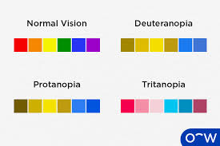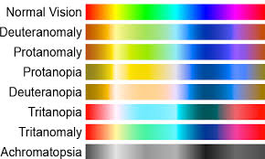
Color blindness is much more common in men than women because the most common types are linked to the X chromosome.
Overall, about 1 in 12 men (8%) and 1 in 200 women (0.5%) have some form of color vision deficiency.

Red-Green (99% of cases)
This is by far the most common category.
- Deuteranomaly (Green-weak): ~5.0% of men. The most common type.
- Deuteranopia (Green-blind): ~1.0% of men.
- Protanomaly (Red-weak): ~1.0% of men.
- Protanopia (Red-blind): ~1.0% of men.

Blue-Yellow & Total (Very Rare)
These affect men and women equally because they aren't linked to the X chromosome.
- Tritanomaly / Tritanopia (Blue-weak/blind): Less than 0.01% of the population (roughly 1 in 10,000).
- Achromatopsia (Total): Extremely rare, affecting about 0.003% (roughly 1 in 33,000).

Color Palette Options

Color Palette (1)
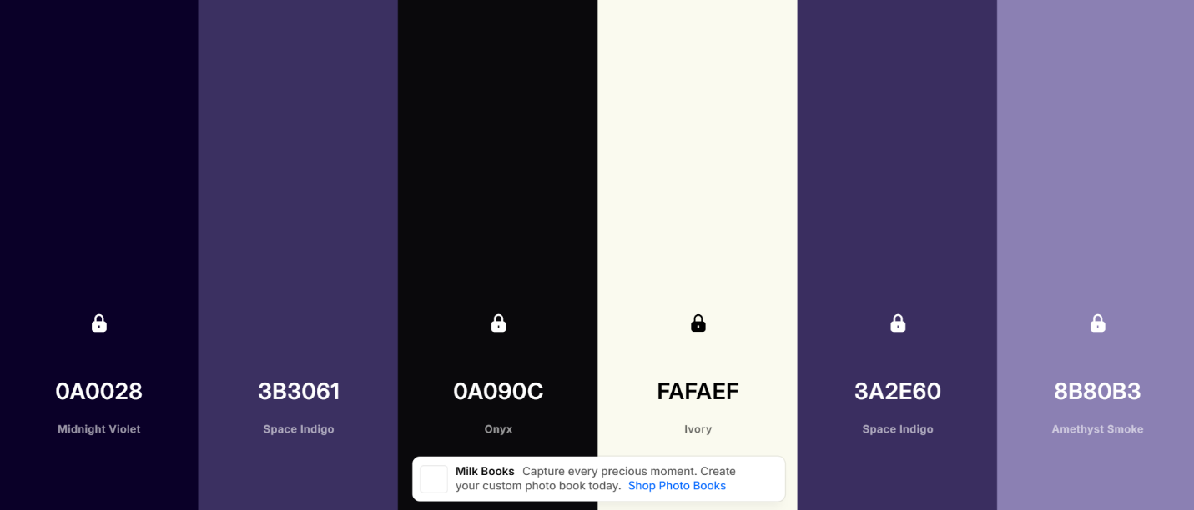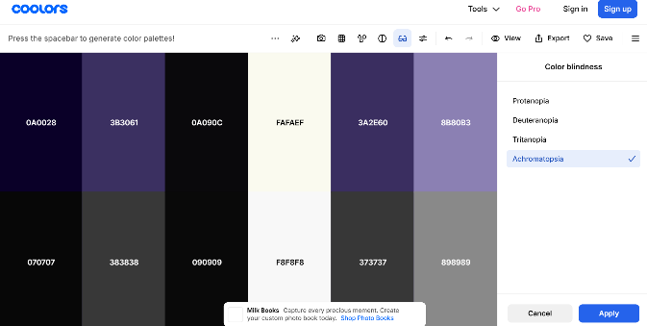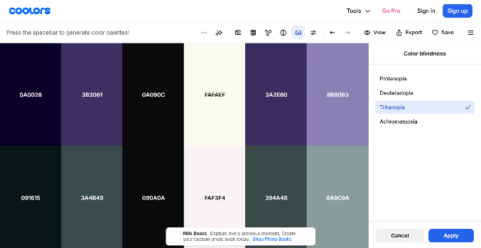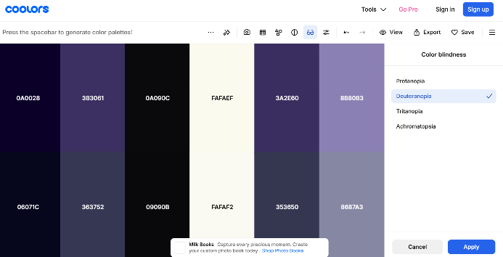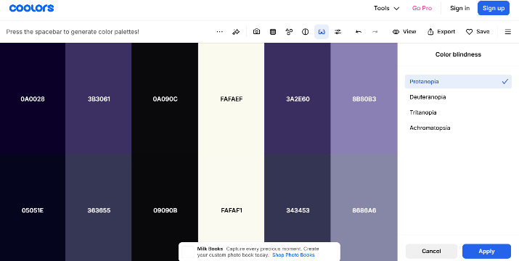

Color Palette (2)
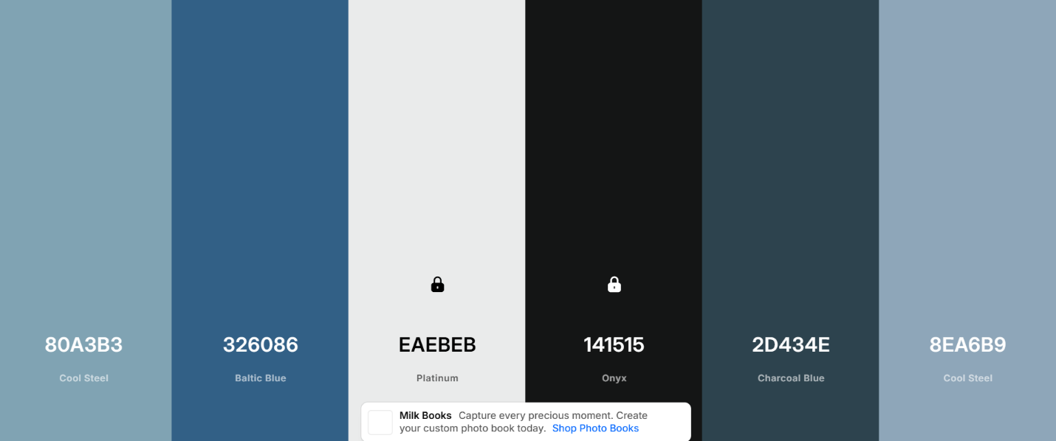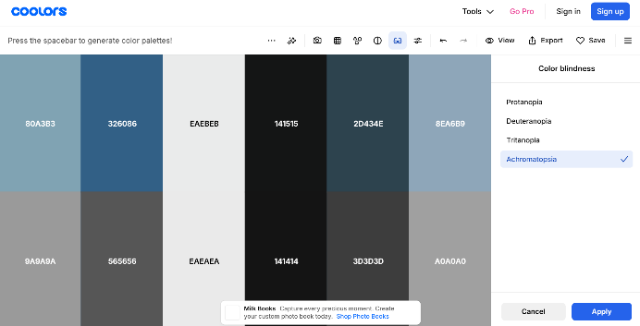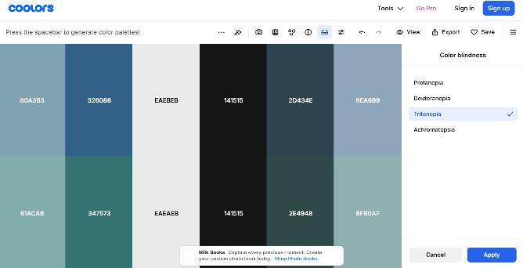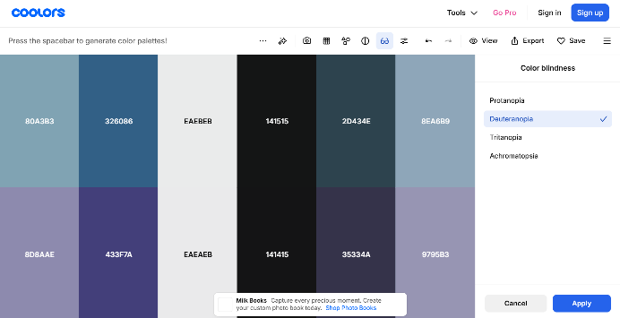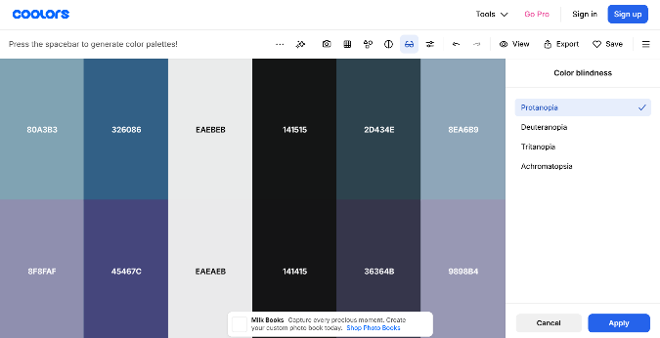

Color Palette (3)
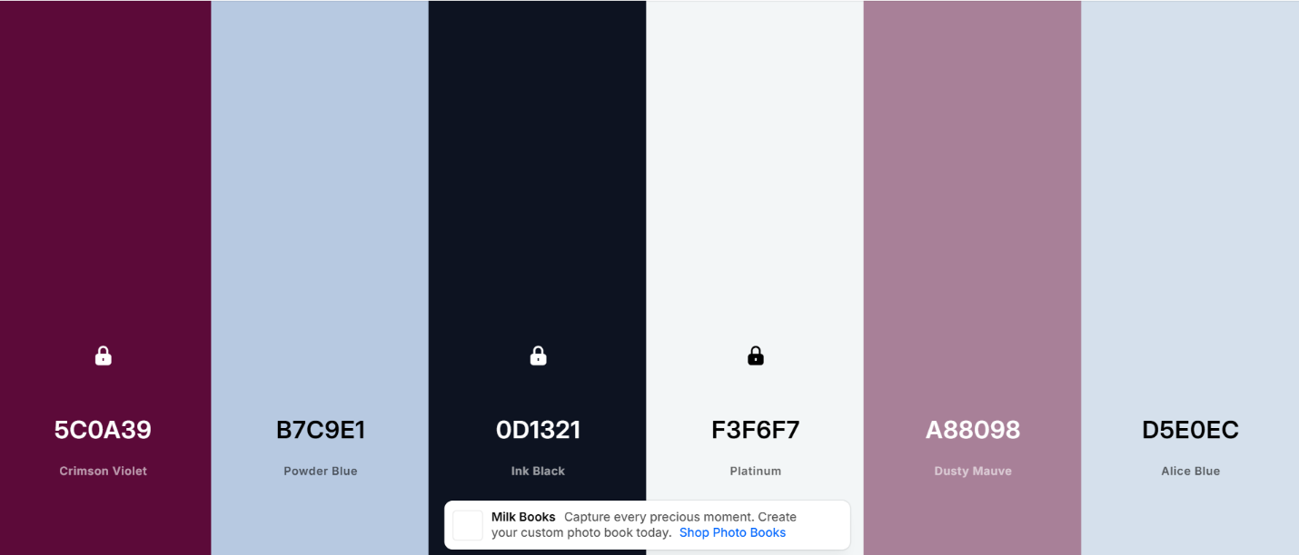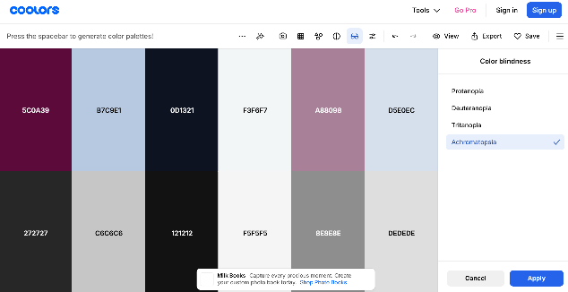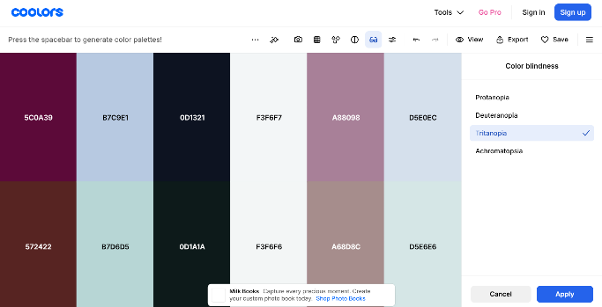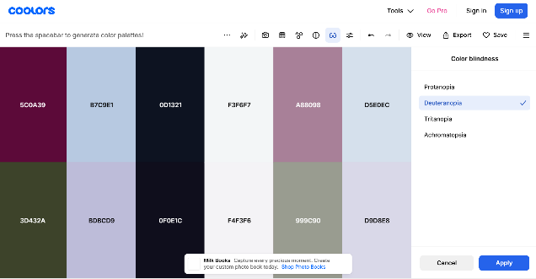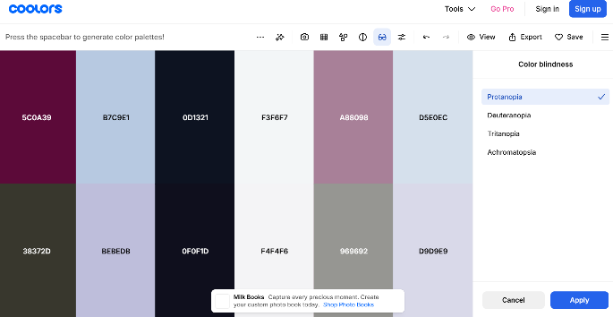

Color Palette (4)
